Overview
This file is a specification of the model created by UML definition

Package List
Full Name | Summary
[Root]

[Root] Package

UseCase List
Name | Summary
Selecionar Empresa
UC 01 - Manter Usuários
UC 01.1 - Manter Gerente
UC 01.2 - Manter Funcionarios
UC 02 - Gerenciar empresas
UC 03 - Gerenciar acesso (login)
UC 04 - Manter controle contabil
UC 04.1 - Manter Controle Contábil
UC 04.1 - Selecioar Empresa
UC 04.1.1 - Incluir novo controle
UC 04.1.2 - Consultar Controles
UC 04.1.3 - Consultar Observação
UC 04.1.4 - Incluir Observação
UC 04.1.5 - Alterar status da Observação
UC 04.1.7 - Alterar Controle
UC 05 - Manter observações
UC 06 - Gerenciar dados de pagamentos e recebimentos convertidos
UC 06.1 - Listar Opções de Importação
UC 06.2 - Importar Recebimentos
UC 06.3 - Importar Pagamentos
UC 06.4 - Importar Cartões
UC 06.5 - Escolher Arquivo de Importação
UC 06.6 - Confrontar arquivos
UC 07 - Manter plano de contas
UC 07.1 - Listar Plano de Contas
UC 07.2 - Incluir Plano de Contas
UC 07.3 - Alterar Plano de Contas
UC 07.4 - Excluir Plano de Contas
UC 08 - Gerar relatório de controle contábil
UC 09 - Gravar temporariamente os arquivos convertidos
UC 10 - Gravar o layout dos arquivos
UC 4.1.6 - Alterar Observação

Classifier List
Name | Type | Summary
Funcionarios | Actor
Gerente | Actor
Usuarios | Entity

Diagram

Caso de uso Geral[UseCase Diagram]

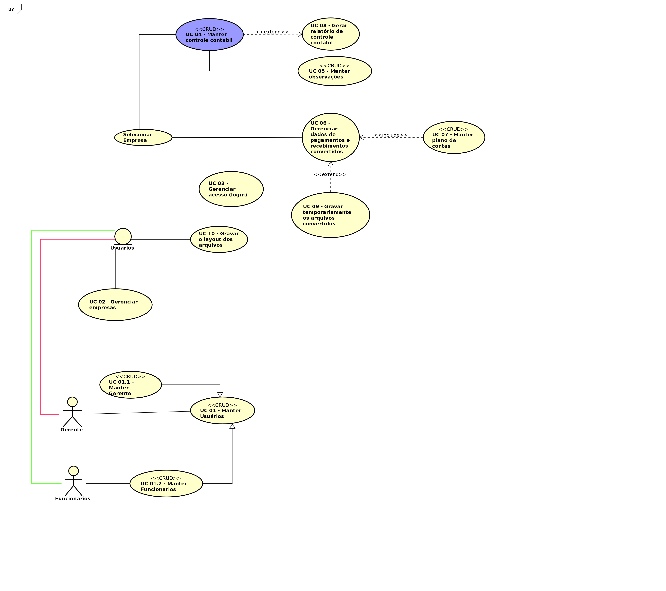

figure 1: Caso de uso Geral[UseCase Diagram]

UC 04 - Controle Contábil[UseCase Diagram]

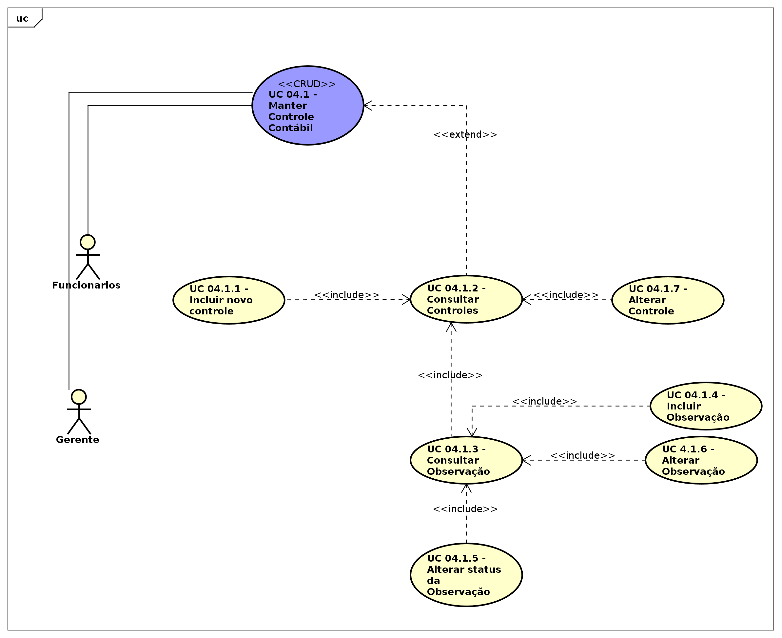

figure 2: UC 04 - Controle Contábil[UseCase Diagram]

UC 06 - Importador[UseCase Diagram]

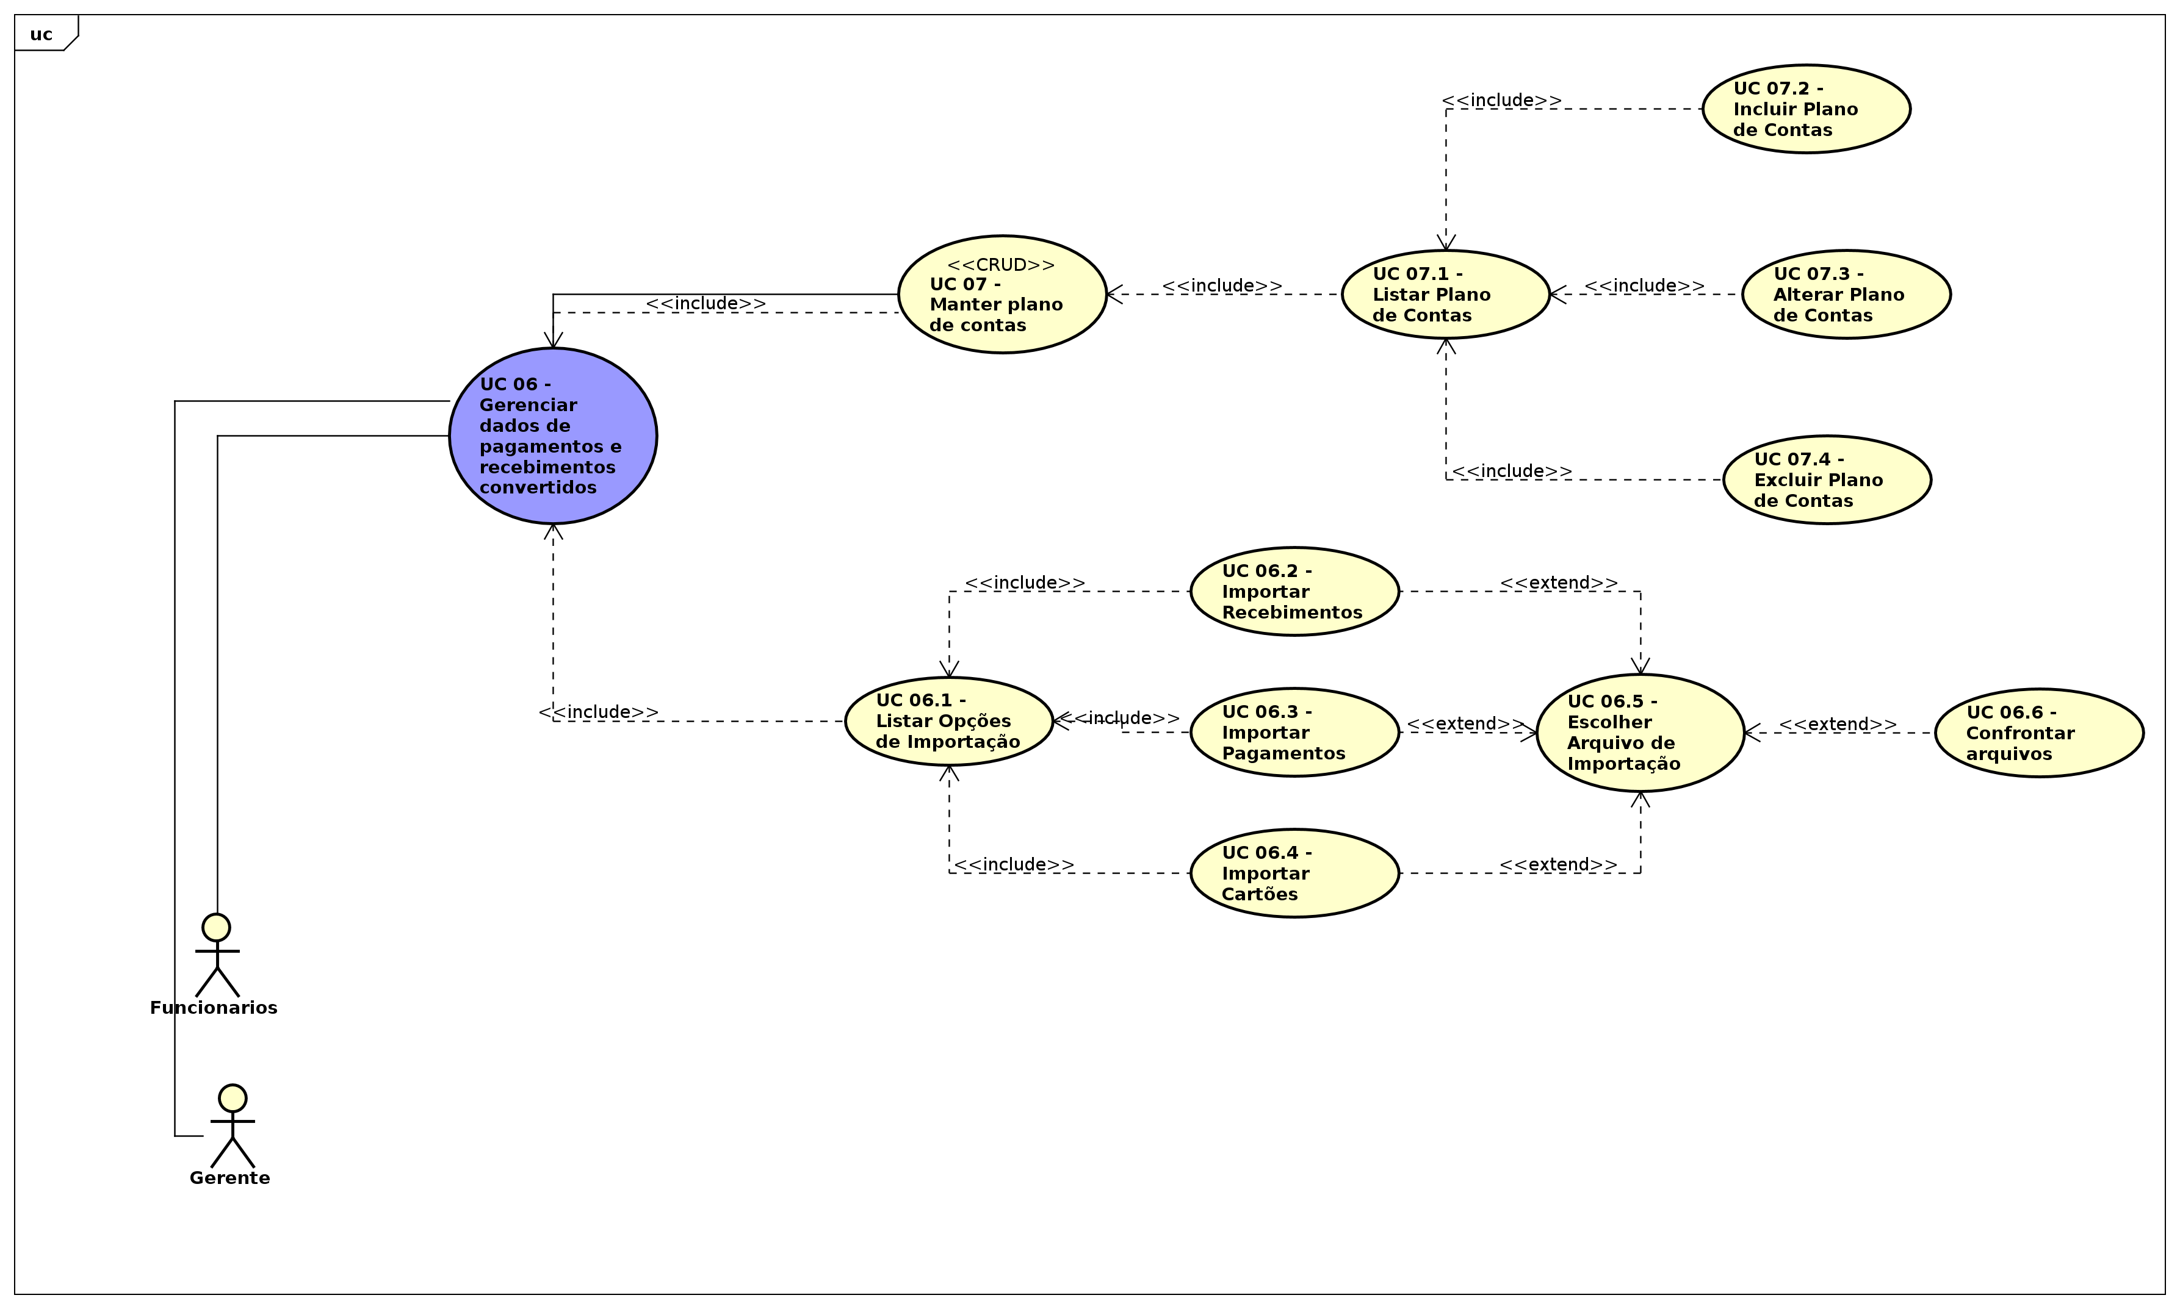

figure 3: UC 06 - Importador[UseCase Diagram]

UseCase

Selecionar Empresa [UseCase]

Namespace
[Root]

Relation (From Source To Target)
Name | Type | Target | Summary
 | Association | UC 04 - Manter controle contabil
 | Association | UC 06 - Gerenciar dados de pagamentos e recebimentos convertidos
 | Association | UC 04 - Manter controle contabil
 | Association | UC 06 - Gerenciar dados de pagamentos e recebimentos convertidos
 | Association | UC 07 - Manter plano de contas

Relation (From Target To Source)
Name | Type | Source | Summary
 | Include | UC 06 - Gerenciar dados de pagamentos e recebimentos convertidos
 | Include | UC 04 - Manter controle contabil

UseCase Description
Template | Astah Original
UseCase | Selecionar Empresa
Summary
Actor
Precondition
Postcondition
Base Sequence
Branch Sequence
Exception Sequence
Sub UseCase
Note

UC 01 - Manter Usuários [UseCase]

Namespace
[Root]

Stereotype
<<CRUD>>

UseCase Description
Template | Astah Original
UseCase | [CRUD]UC 01 - Manter Usuários
Summary
Actor | Gerente
Precondition
Postcondition
Base Sequence
Branch Sequence
Exception Sequence
Sub UseCase | UC 03 - Gerenciar acesso (login)
Note

UC 01.1 - Manter Gerente [UseCase]

Namespace
[Root]

Stereotype
<<CRUD>>

Relation (From Source To Target)
Name | Type | Target | Summary
 | Generalization | UC 01 - Manter Usuários

UseCase Description
Template | Astah Original
UseCase | [CRUD]UC 01.1 - Manter Gerente
Summary
Actor
Precondition
Postcondition
Base Sequence
Branch Sequence
Exception Sequence
Sub UseCase
Note

UC 01.2 - Manter Funcionarios [UseCase]

Namespace
[Root]

Stereotype
<<CRUD>>

Relation (From Source To Target)
Name | Type | Target | Summary
 | Generalization | UC 01 - Manter Usuários

UseCase Description
Template | Astah Original
UseCase | [CRUD]UC 01.2 - Manter Funcionarios
Summary
Actor | Funcionarios
Precondition
Postcondition
Base Sequence
Branch Sequence
Exception Sequence
Sub UseCase
Note

UC 02 - Gerenciar empresas [UseCase]

Namespace
[Root]

Relation (From Source To Target)
Name | Type | Target | Summary
 | Association | UC 07 - Manter plano de contas

UseCase Description
Template | Astah Original
UseCase | UC 02 - Gerenciar empresas
Summary
Actor
Precondition
Postcondition
Base Sequence
Branch Sequence
Exception Sequence
Sub UseCase | UC 09 - Gravar temporariamente os arquivos convertidos
Note

UC 03 - Gerenciar acesso (login) [UseCase]

Namespace
[Root]

Relation (From Target To Source)
Name | Type | Source | Summary
 | Include | UC 01 - Manter Usuários

UseCase Description
Template | Astah Original
UseCase | UC 03 - Gerenciar acesso (login)
Summary
Actor
Precondition
Postcondition
Base Sequence
Branch Sequence
Exception Sequence
Sub UseCase
Note

UC 04 - Manter controle contabil [UseCase]

Namespace
[Root]

Stereotype
<<CRUD>>

Relation (From Source To Target)
Name | Type | Target | Summary
 | Association | UC 05 - Manter observações
 | Association | UC 05 - Manter observações
 | Association | Selecionar Empresa
 | Extend | UC 08 - Gerar relatório de controle contábil

UseCase Description
Template | Astah Original
UseCase | [CRUD]UC 04 - Manter controle contabil
Summary
Actor
Precondition
Postcondition
Base Sequence
Branch Sequence
Exception Sequence
Sub UseCase | UC 08 - Gerar relatório de controle contábil,  Selecionar Empresa
Note

UC 04.1 - Manter Controle Contábil [UseCase]

Namespace
[Root]

Stereotype
<<CRUD>>

UseCase Description
Template | Astah Original
UseCase | [CRUD]UC 04.1 - Manter Controle Contábil
Summary
Actor | Funcionarios,  Gerente
Precondition
Postcondition
Base Sequence
Branch Sequence
Exception Sequence
Sub UseCase
Note

UC 04.1 - Selecioar Empresa [UseCase]

Namespace
[Root]

Relation (From Source To Target)
Name | Type | Target | Summary
 | Extend | UC 04.1 - Manter Controle Contábil

UseCase Description
Template | Astah Original
UseCase | UC 04.1 - Selecioar Empresa
Summary
Actor
Precondition
Postcondition
Base Sequence
Branch Sequence
Exception Sequence
Sub UseCase
Note

UC 04.1.1 - Incluir novo controle [UseCase]

Namespace
[Root]

Relation (From Source To Target)
Name | Type | Target | Summary
 | Extend | UC 04.1 - Manter Controle Contábil
 | Extend | UC 04.1 - Manter Controle Contábil

UseCase Description
Template | Astah Original
UseCase | UC 04.1.1 - Incluir novo controle
Summary
Actor
Precondition
Postcondition
Base Sequence
Branch Sequence
Exception Sequence
Sub UseCase | UC 04.1.2 - Consultar Controles
Note

UC 04.1.2 - Consultar Controles [UseCase]

Namespace
[Root]

Relation (From Source To Target)
Name | Type | Target | Summary
 | Extend | UC 04.1 - Manter Controle Contábil
 | Extend | UC 04.1 - Manter Controle Contábil

Relation (From Target To Source)
Name | Type | Source | Summary
 | Include | UC 04.1.1 - Incluir novo controle
 | Include | UC 04.1.3 - Consultar Observação
 | Include | UC 04.1.7 - Alterar Controle

UseCase Description
Template | Astah Original
UseCase | UC 04.1.2 - Consultar Controles
Summary
Actor
Precondition
Postcondition
Base Sequence
Branch Sequence
Exception Sequence
Sub UseCase
Note

UC 04.1.3 - Consultar Observação [UseCase]

Namespace
[Root]

Relation (From Target To Source)
Name | Type | Source | Summary
 | Include | UC 04.1.5 - Alterar status da Observação
 | Include | UC 4.1.6 - Alterar Observação
 | Include | UC 04.1.4 - Incluir Observação

UseCase Description
Template | Astah Original
UseCase | UC 04.1.3 - Consultar Observação
Summary
Actor
Precondition
Postcondition
Base Sequence
Branch Sequence
Exception Sequence
Sub UseCase | UC 04.1.2 - Consultar Controles
Note

UC 04.1.4 - Incluir Observação [UseCase]

Namespace
[Root]

UseCase Description
Template | Astah Original
UseCase | UC 04.1.4 - Incluir Observação
Summary
Actor
Precondition
Postcondition
Base Sequence
Branch Sequence
Exception Sequence
Sub UseCase | UC 04.1.3 - Consultar Observação
Note

UC 04.1.5 - Alterar status da Observação [UseCase]

Namespace
[Root]

UseCase Description
Template | Astah Original
UseCase | UC 04.1.5 - Alterar status da Observação
Summary
Actor
Precondition
Postcondition
Base Sequence
Branch Sequence
Exception Sequence
Sub UseCase | UC 04.1.3 - Consultar Observação
Note

UC 04.1.7 - Alterar Controle [UseCase]

Namespace
[Root]

UseCase Description
Template | Astah Original
UseCase | UC 04.1.7 - Alterar Controle
Summary
Actor
Precondition
Postcondition
Base Sequence
Branch Sequence
Exception Sequence
Sub UseCase | UC 04.1.2 - Consultar Controles
Note

UC 05 - Manter observações [UseCase]

Namespace
[Root]

Stereotype
<<CRUD>>

UseCase Description
Template | Astah Original
UseCase | [CRUD]UC 05 - Manter observações
Summary
Actor
Precondition
Postcondition
Base Sequence
Branch Sequence
Exception Sequence
Sub UseCase
Note

UC 06 - Gerenciar dados de pagamentos e recebimentos convertidos [UseCase]

Namespace
[Root]

Relation (From Source To Target)
Name | Type | Target | Summary
 | Association | UC 07 - Manter plano de contas
 | Association | Selecionar Empresa

Relation (From Target To Source)
Name | Type | Source | Summary
 | Include | UC 06.1 - Listar Opções de Importação
 | Include | UC 07 - Manter plano de contas

UseCase Description
Template | Astah Original
UseCase | UC 06 - Gerenciar dados de pagamentos e recebimentos convertidos
Summary
Actor | Funcionarios,  Gerente
Precondition
Postcondition
Base Sequence
Branch Sequence
Exception Sequence
Sub UseCase | Selecionar Empresa
Note

UC 06.1 - Listar Opções de Importação [UseCase]

Namespace
[Root]

Relation (From Target To Source)
Name | Type | Source | Summary
 | Include | UC 06.2 - Importar Recebimentos
 | Include | UC 06.3 - Importar Pagamentos
 | Include | UC 06.4 - Importar Cartões

UseCase Description
Template | Astah Original
UseCase | UC 06.1 - Listar Opções de Importação
Summary
Actor
Precondition
Postcondition
Base Sequence
Branch Sequence
Exception Sequence
Sub UseCase | UC 06 - Gerenciar dados de pagamentos e recebimentos convertidos
Note

UC 06.2 - Importar Recebimentos [UseCase]

Namespace
[Root]

Relation (From Source To Target)
Name | Type | Target | Summary
 | Extend | UC 06.5 - Escolher Arquivo de Importação

UseCase Description
Template | Astah Original
UseCase | UC 06.2 - Importar Recebimentos
Summary
Actor
Precondition
Postcondition
Base Sequence
Branch Sequence
Exception Sequence
Sub UseCase | UC 06.1 - Listar Opções de Importação
Note

UC 06.3 - Importar Pagamentos [UseCase]

Namespace
[Root]

Relation (From Source To Target)
Name | Type | Target | Summary
 | Extend | UC 06.5 - Escolher Arquivo de Importação

UseCase Description
Template | Astah Original
UseCase | UC 06.3 - Importar Pagamentos
Summary
Actor
Precondition
Postcondition
Base Sequence
Branch Sequence
Exception Sequence
Sub UseCase | UC 06.1 - Listar Opções de Importação
Note

UC 06.4 - Importar Cartões [UseCase]

Namespace
[Root]

Relation (From Source To Target)
Name | Type | Target | Summary
 | Extend | UC 06.5 - Escolher Arquivo de Importação

UseCase Description
Template | Astah Original
UseCase | UC 06.4 - Importar Cartões
Summary
Actor
Precondition
Postcondition
Base Sequence
Branch Sequence
Exception Sequence
Sub UseCase | UC 06.1 - Listar Opções de Importação
Note

UC 06.5 - Escolher Arquivo de Importação [UseCase]

Namespace
[Root]

UseCase Description
Template | Astah Original
UseCase | UC 06.5 - Escolher Arquivo de Importação
Summary
Actor
Precondition
Postcondition
Base Sequence
Branch Sequence
Exception Sequence
Sub UseCase
Note

UC 06.6 - Confrontar arquivos [UseCase]

Namespace
[Root]

Relation (From Source To Target)
Name | Type | Target | Summary
 | Extend | UC 06.5 - Escolher Arquivo de Importação

UseCase Description
Template | Astah Original
UseCase | UC 06.6 - Confrontar arquivos
Summary
Actor
Precondition
Postcondition
Base Sequence
Branch Sequence
Exception Sequence
Sub UseCase
Note

UC 07 - Manter plano de contas [UseCase]

Namespace
[Root]

Stereotype
<<CRUD>>

Relation (From Target To Source)
Name | Type | Source | Summary
 | Include | UC 07.1 - Listar Plano de Contas

UseCase Description
Template | Astah Original
UseCase | [CRUD]UC 07 - Manter plano de contas
Summary
Actor
Precondition
Postcondition
Base Sequence
Branch Sequence
Exception Sequence
Sub UseCase | UC 06 - Gerenciar dados de pagamentos e recebimentos convertidos
Note

UC 07.1 - Listar Plano de Contas [UseCase]

Namespace
[Root]

Relation (From Source To Target)
Name | Type | Target | Summary
 | Extend | UC 07 - Manter plano de contas

Relation (From Target To Source)
Name | Type | Source | Summary
 | Include | UC 07.2 - Incluir Plano de Contas
 | Include | UC 07.3 - Alterar Plano de Contas
 | Include | UC 07.4 - Excluir Plano de Contas

UseCase Description
Template | Astah Original
UseCase | UC 07.1 - Listar Plano de Contas
Summary
Actor
Precondition
Postcondition
Base Sequence
Branch Sequence
Exception Sequence
Sub UseCase | [CRUD]UC 07 - Manter plano de contas
Note

UC 07.2 - Incluir Plano de Contas [UseCase]

Namespace
[Root]

UseCase Description
Template | Astah Original
UseCase | UC 07.2 - Incluir Plano de Contas
Summary
Actor
Precondition
Postcondition
Base Sequence
Branch Sequence
Exception Sequence
Sub UseCase | UC 07.1 - Listar Plano de Contas
Note

UC 07.3 - Alterar Plano de Contas [UseCase]

Namespace
[Root]

UseCase Description
Template | Astah Original
UseCase | UC 07.3 - Alterar Plano de Contas
Summary
Actor
Precondition
Postcondition
Base Sequence
Branch Sequence
Exception Sequence
Sub UseCase | UC 07.1 - Listar Plano de Contas
Note

UC 07.4 - Excluir Plano de Contas [UseCase]

Namespace
[Root]

UseCase Description
Template | Astah Original
UseCase | UC 07.4 - Excluir Plano de Contas
Summary
Actor
Precondition
Postcondition
Base Sequence
Branch Sequence
Exception Sequence
Sub UseCase | UC 07.1 - Listar Plano de Contas
Note

UC 08 - Gerar relatório de controle contábil [UseCase]

Namespace
[Root]

Relation (From Target To Source)
Name | Type | Source | Summary
 | Include | UC 04 - Manter controle contabil

UseCase Description
Template | Astah Original
UseCase | UC 08 - Gerar relatório de controle contábil
Summary
Actor
Precondition
Postcondition
Base Sequence
Branch Sequence
Exception Sequence
Sub UseCase
Note

UC 09 - Gravar temporariamente os arquivos convertidos [UseCase]

Namespace
[Root]

Relation (From Source To Target)
Name | Type | Target | Summary
 | Extend | UC 06 - Gerenciar dados de pagamentos e recebimentos convertidos

Relation (From Target To Source)
Name | Type | Source | Summary
 | Include | UC 02 - Gerenciar empresas

UseCase Description
Template | Astah Original
UseCase | UC 09 - Gravar temporariamente os arquivos convertidos
Summary
Actor
Precondition
Postcondition
Base Sequence
Branch Sequence
Exception Sequence
Sub UseCase | UC 10 - Gravar o layout dos arquivos
Note

UC 10 - Gravar o layout dos arquivos [UseCase]

Namespace
[Root]

Relation (From Target To Source)
Name | Type | Source | Summary
 | Include | UC 09 - Gravar temporariamente os arquivos convertidos

UseCase Description
Template | Astah Original
UseCase | UC 10 - Gravar o layout dos arquivos
Summary
Actor
Precondition
Postcondition
Base Sequence
Branch Sequence
Exception Sequence
Sub UseCase
Note

UC 4.1.6 - Alterar Observação [UseCase]

Namespace
[Root]

UseCase Description
Template | Astah Original
UseCase | UC 4.1.6 - Alterar Observação
Summary
Actor
Precondition
Postcondition
Base Sequence
Branch Sequence
Exception Sequence
Sub UseCase | UC 04.1.3 - Consultar Observação
Note

Class

Funcionarios [Actor]

Declaration
public class Funcionarios

Namespace
[Root]

Stereotype
<<actor>>

Relation (From Source To Target)
Name | Type | Target | Summary
 | Association | UC 01.2 - Manter Funcionarios
 | Association | Usuarios
 | Association | UC 04.1 - Manter Controle Contábil
 | Association | UC 06 - Gerenciar dados de pagamentos e recebimentos convertidos

Gerente [Actor]

Declaration
public class Gerente

Namespace
[Root]

Stereotype
<<actor>>

Relation (From Source To Target)
Name | Type | Target | Summary
 | Association | UC 01 - Manter Usuários
 | Association | Usuarios
 | Association | UC 04.1 - Manter Controle Contábil
 | Association | UC 06 - Gerenciar dados de pagamentos e recebimentos convertidos

Usuarios [Entity]

Declaration
public class Usuarios

Namespace
[Root]

Stereotype
<<entity>>

Relation (From Source To Target)
Name | Type | Target | Summary
 | Association | UC 03 - Gerenciar acesso (login)
 | Association | UC 02 - Gerenciar empresas
 | Association | UC 04 - Manter controle contabil
 | Association | UC 05 - Manter observações
 | Association | UC 06 - Gerenciar dados de pagamentos e recebimentos convertidos
 | Association | UC 07 - Manter plano de contas
 | Association | Selecionar Empresa
 | Association | Selecionar Empresa
 | Association | UC 10 - Gravar o layout dos arquivos

